
The 19th Annual Scientific Meeting of The Korean Pediatric Heart Society

1. GUEST INFORMATION
First Name: | Last Name: |  | (  Mr.  Ms.)
Affiliation:
Address: |  | Country:
Phone: | Fax: | Email:
Accompanying Person（ Mr.  Ms.) | First Name: | Last Name:
Check-in Date: | Check-out Date: | No. of Nights ( )
Check-in Time: | Special Request:

2. HOTEL AND ROOM PREFERENCE
Hotels | Date | Room | Special Room Rates
 Grand Walkerhill Seoul | 4~7, Apr, 2019 | 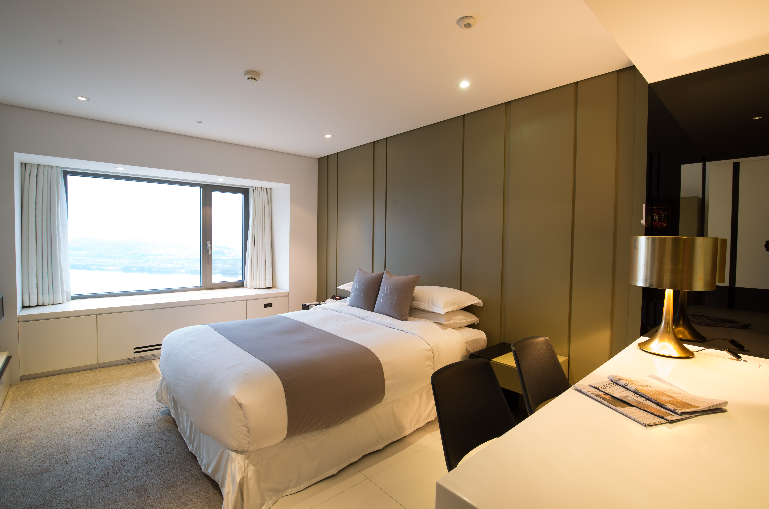 | KRW 210,000   Double Bed /   Twin Beds
 Vista Walkerhill Seoul | 4~7, Apr, 2019 | 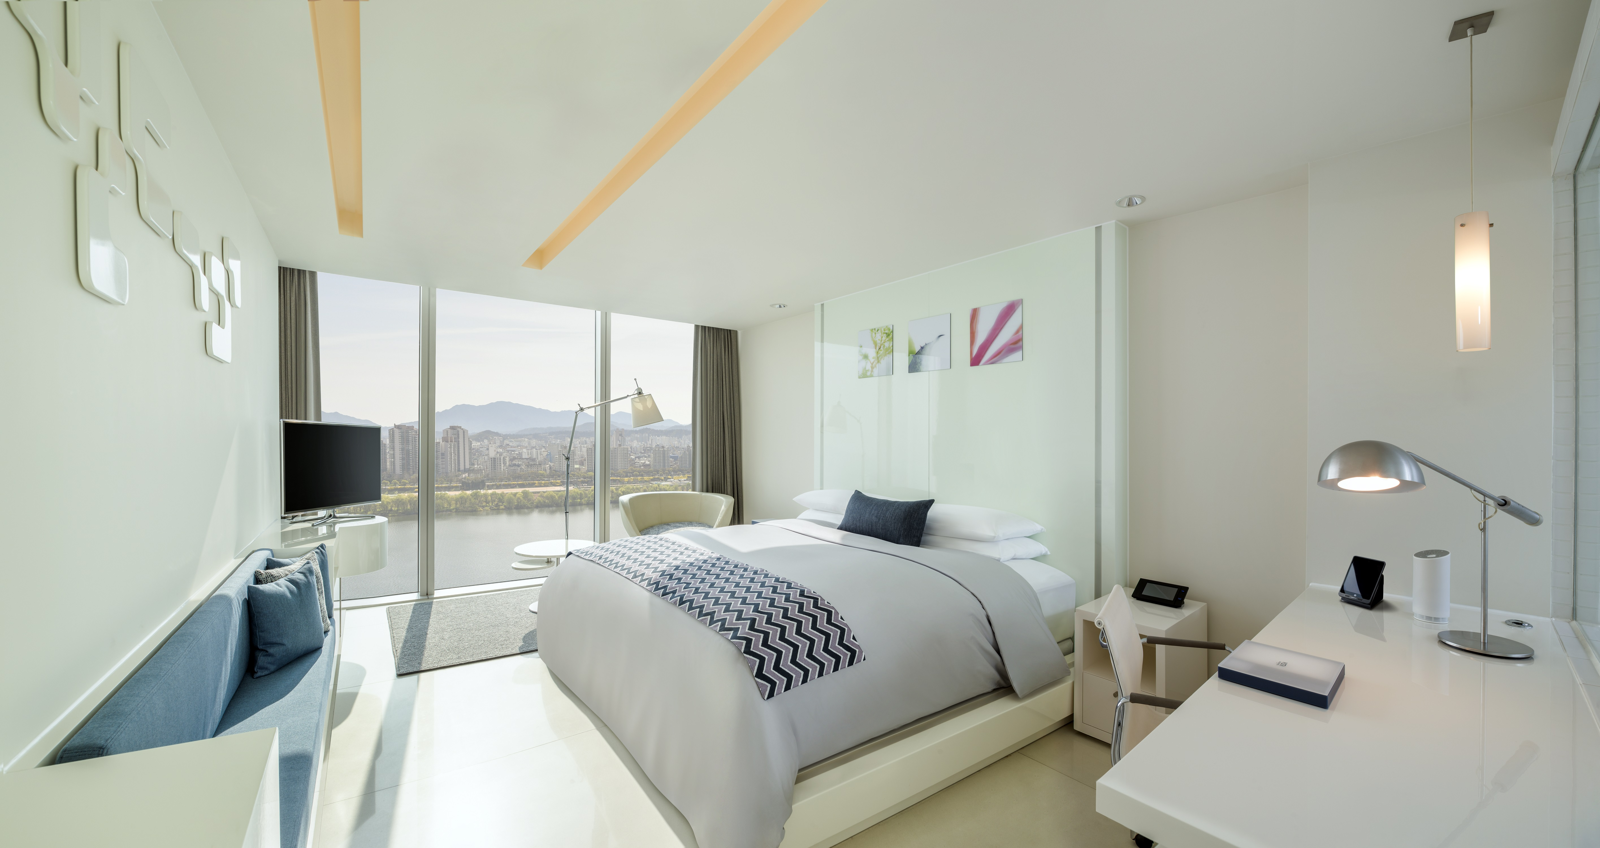 | KRW 250,000   Double Bed /   Twin Beds
* Notes 1. The hotel will send you the confirmation for your room reservation.
2. All room rates are subject to 10% service charge & 10% government tax.
3. Complimentary internet service in the Rooms
4. Free access to fitness center and swimming pool.
5. Breakfast: KRW 33,880 will be added.
6. Check in time is 15:00 & Check out time is 12:00.

3. PAYMENT INFORMATION

* In order to guarantee your room reservation, your credit card information must be accompanied.
Card Type |  Amex  Diners  Euro Card  JCB  Master  VISA | Card No.
Exp. Date | / (MM/YY) | Signature

* Cancellation Policy
- Reservation is modifiable by 18:00PM on the 5-day before guest arrival.
- If guest fails to change or cancel before applied time on policy, one-night penalty charge will be applied.
- All policies are based on hotel time
* in charge . Ms Anny Park / Ms Jinhee Ju
Tel: 02-2022-0565, 0564 / Fax: 02-2022-0567 / Email: shpark3@sk.com, roisin.ju@sk.com
위치: 서울시 광진구 워커힐로 177

